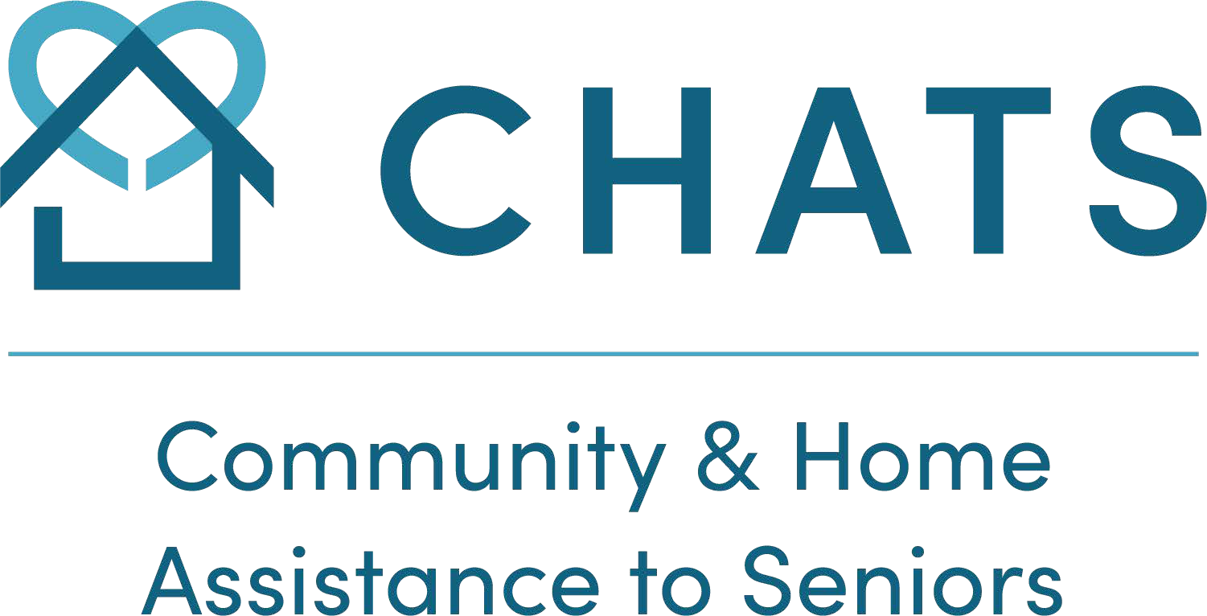

Fact Sheet

Woodbridge Adult Day Program
Seniors & Adults (18+)
Frail, Socially Isolated, Mild Cognitive Impairment, or diagnosed with an age-related illness.

Service Description: | A full-day community-based program, offering respite to caregivers and providing older adults with individualized plans of care. The program includes a variety of social and wellness activities, companionship, nutritious snacks, and lunch, in a safe, friendly, and caring environment while addressing social isolation for older adults. Activities include exercise, mental stimulation, crafts, outings, relaxation programs, entertainment, health promotion, and disease prevention. Programs are also being offered virtually.
Service Provider(s): | Specially-trained, multi-disciplinary teams that include a Program Supervisor, Recreation Programmers, Personal Support Workers, trained volunteers and Gerontology/Recreation students.
Persons Served: | Older adults who are frail, socially isolated, and/or may have mild to moderate cognitive impairment (without responsive behaviours) and who could benefit from a secure environment and adults with an age-related illness who could benefit from therapeutic recreation, personal support and structured, goal-oriented programming.
Eligibility: | - Person served is 18 years of age or older with an age-related illness  - Person served or substitute decision maker consents to participate in an initial (and regular follow up) RAI CHA evidence based assessment to determine individualized care needs and develop a care plan and goals.  - Person served lives in the community and benefits from supervision during the day  - Person served requires minimal assistance with activities of daily living (e.g. meal, toileting and transfers - maximum one- person transfer)  - Person served may have caregiver who requires respite  - Person served will benefit from a friendly, interactive, stimulating recreation programming  - Person served adhere to our personal support worker administered medication program with a recognized medication compliance system (pre-poured system – e.g. blister package)
Limitations: | Older adults with dementia who have responsive behaviors; persons who require more than one personal support worker for transfers/personal care.
Program location(s): | Woodbridge/Vaughan
Availability: | Monday to Friday from 7:30 a.m. to 6:30 p.m. NOTE: Hours of operations have changed due to the Pandemic.
Frequency of Service: | Up to 5 times per week, as assessed by Central LHIN Home and Community Care
Cost: | Daily fees range from $5.50-$27.50 and are geared to income (sliding scale). Exceptional subsidies are available. Cancellation with  24 hours’ notice is $5.50. and No notice of absence is subject to a full fee.  Families are encouraged to drop off and pick up clients or arrange through York Region Transit (YRT) or Wheel Trans (TTC).
Contact: | Please contact our Adult Day Program Supervisor with any questions at 905-713-3373 ext. 6085
Referral Source(s): | Self, Family, Physician, Central LHIN Home and Community Care. Eligibility determined by Home and Community Care.
Funded by: | Central LHIN and co-payment from Person Served.
Stakeholders: | Persons Served and Caregivers

(Revised July 2021)

