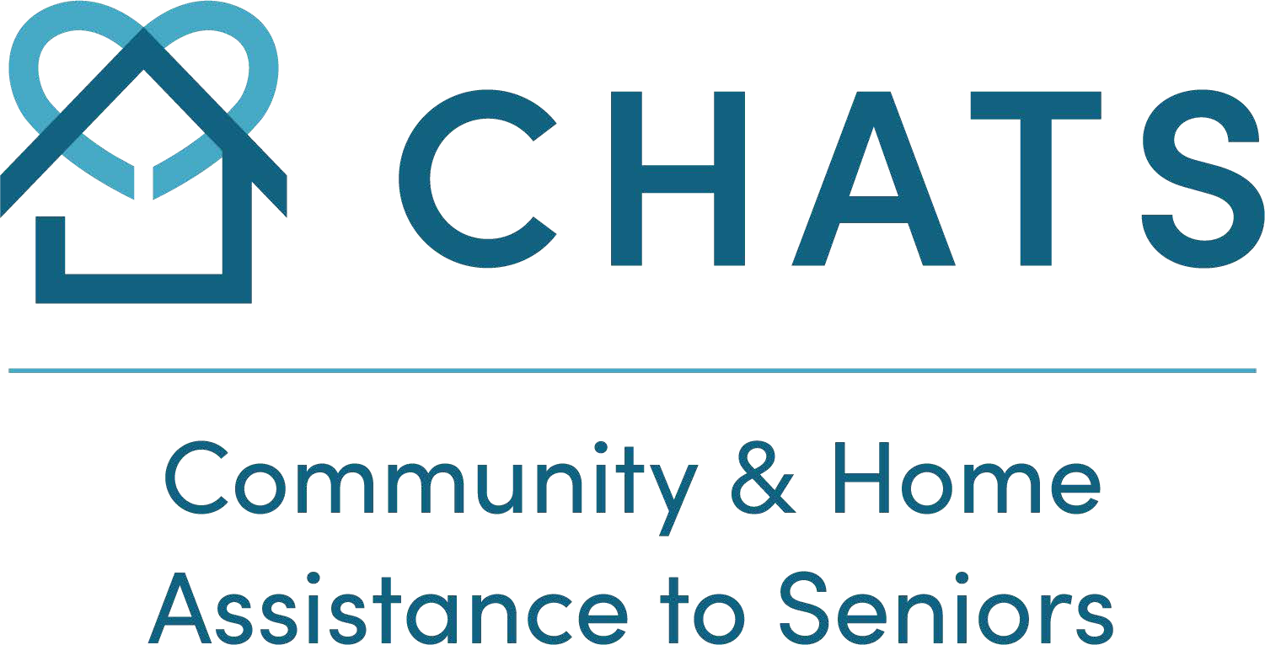

Overnight Respite

Fact Sheet

Service Description: | Short stay (up to 2 weeks) overnight care in a safe, secure house. Services will include personal care, medication management, nutritious meals/snacks, supervision, and activation. Quality, relief for the primary caregiver to prevent caregiver stress, and burnout. The caregiver requiring relief provides direct, ongoing consistent care to the person served. The caregiver is not required to be living with the guest to be eligible for the CHATS Overnight Respite Program.
Service Provider(s): | Personal Support Workers with specialized competencies (skills, knowledge, and education) in senior care.
Persons Served: | Guests with dementia
Eligibility: | - The guest served must have a diagnosis of dementia  - The guest must attend a mandatory trial 2-night stay  - The caregiver must be willing to participate in an assessment visit and care plan  - Staff must be able to manage medications, which must be in a blister pack  - Guests are required to be non-smokers  - Emergency contacts must be available to provide timely response if necessary  - Guests are limited to a maximum of 5 weekends per year  - Most bedrooms are located on the second floor, the ability to navigate stairs based on room availability  - Priority will be given to guests living in York Region and South Simcoe
Program location(s): | 10090 Bathurst Street, Vaughan
Cost: | $100 per night
Referral Source(s): | Family, physicians, Home and Community Care, and other community partners.
Contact: | seniorshelp@chats.on.ca or CHATS office at (905)713-6596 or 1-877-452-4287

November 2025

